VPC Peering
-The combination of two different VPCs as one vpc is known as VPC peering.
-After peering resources in one vpc can access the resources of other vpc.
-the CIDR range of the vpcs should not be overlapping.
-It supports
1.Same account VPCs
2. Same account different region vpc
3. one account to another account vpc
4.one account one region to another account another region vpc.

Task-1 (Implement VPC peering in same region ,same account).
Create two different vpcs .then do the vpc veering and try to access EC2 instance located in other VPC.
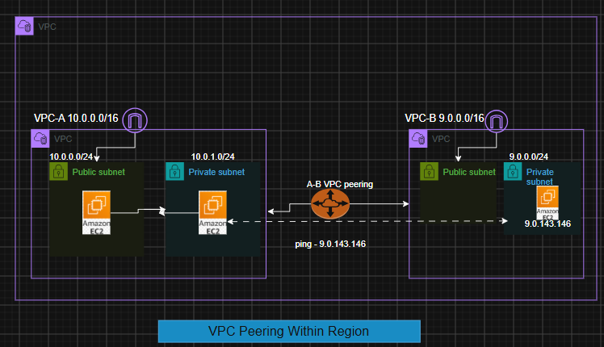

Prerequsite-:
- Two VPCs with two different CIDR . (VPC-A , VPC-B)
- In VPC-A(IGW + 1 public +1 private server{ without NAT} )
- In VPC-B(1 Private server without NAT)
- One VPC peering
Steps-1
- Two VPCs with two different CIDR . (VPC-A ->10.0.0.0/16, VPC-B
->9.0.0.0/16)
- Create one public server and one private server in VPC-A.
- Create VPC-B , create 1 public subnet , 1 private subnet and deploy a private EC2 server (without NAT).
- Now try to make connection Bastion Host ->private Server (VPC-A) -> private server (VPC- B).(it should not allow to ping other server located in vpc B)
- Now create VPC peering for both the server .
  - Give requestor id and acceptor id
  - Update –VPCA route table with VPC-B CIDR range and vice-versa.
[Open VPCA -> Instance id (Ec2 private intance)-> Select Subnet ID-> again subnet ID -> Route Table ID >]
- Now after peering try to communicate with server located in VPC-B via private server of VPC-A . from ec2 private instance of VPC-A

Implementation-
1.Create VPC –A (10.0.0.0/16)
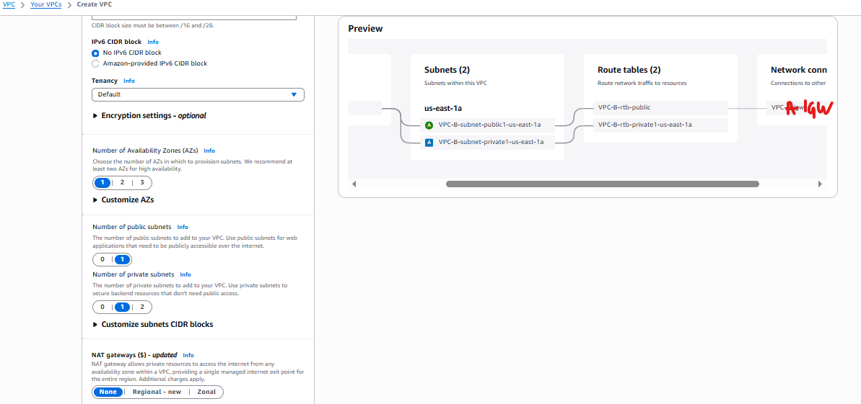

Create VPC- B (9.0.0.0/16)
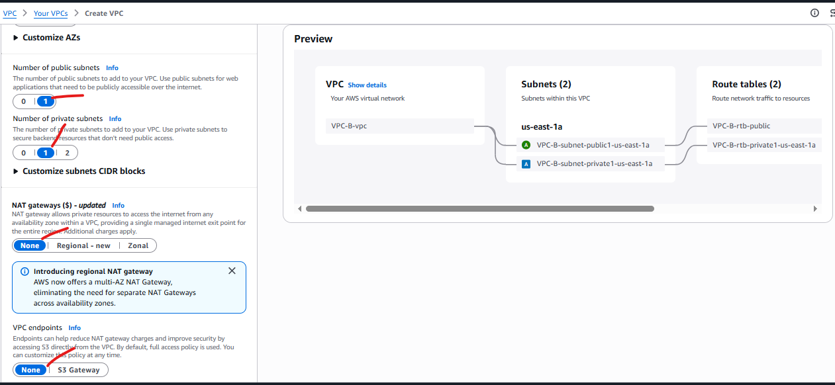
2.VPCs created
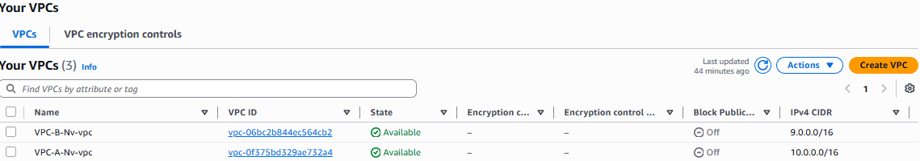

3. Create one public server and one private server in VPC-A.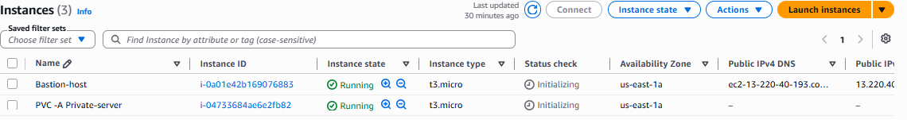
4.Create VPC-B (1 public and 1 private subnet) and deploy a private server without NAT
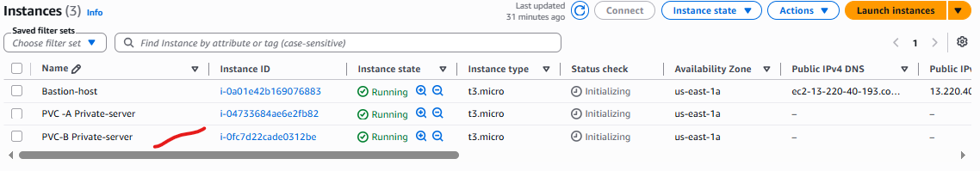
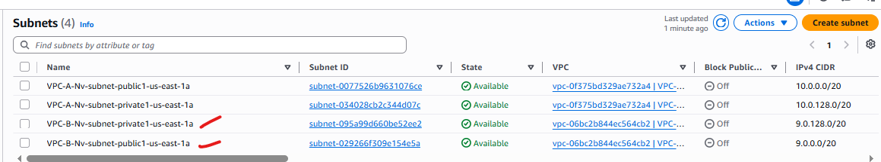
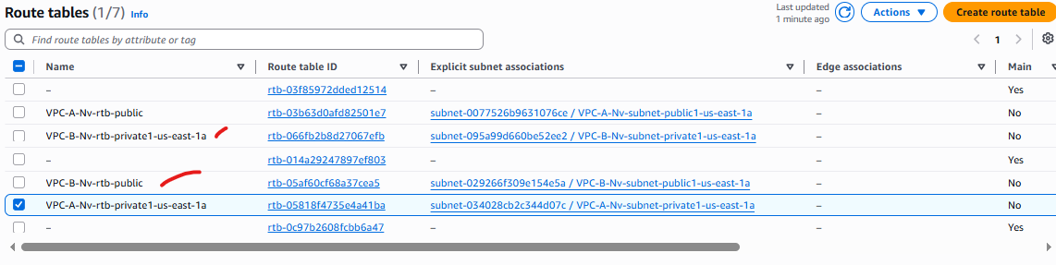

Now login into Bastion server of VPC-A VPC-A Private server and try to ping private EC2 of VPC-B (Private-server-vpc-b)
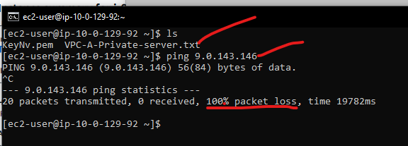 so the server is not pingable .

Now create VPC peering for both the server.
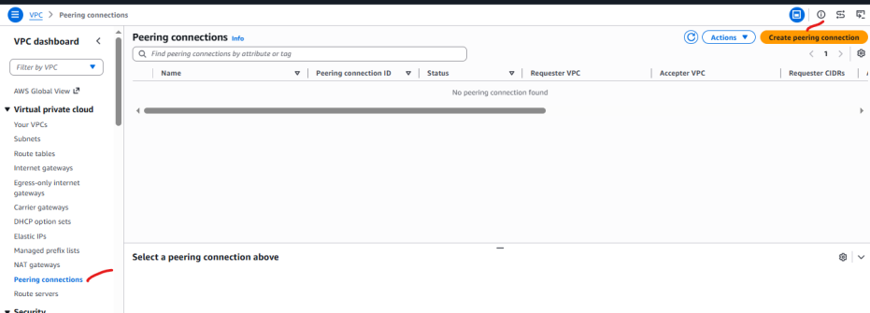

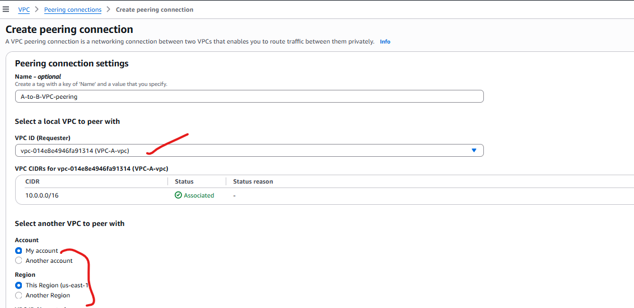

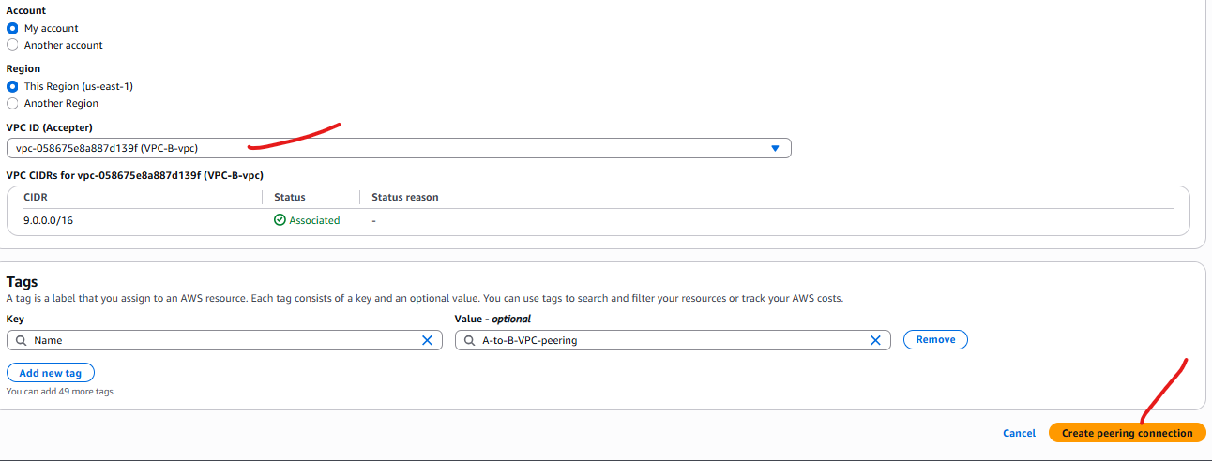

Now accept the peering request
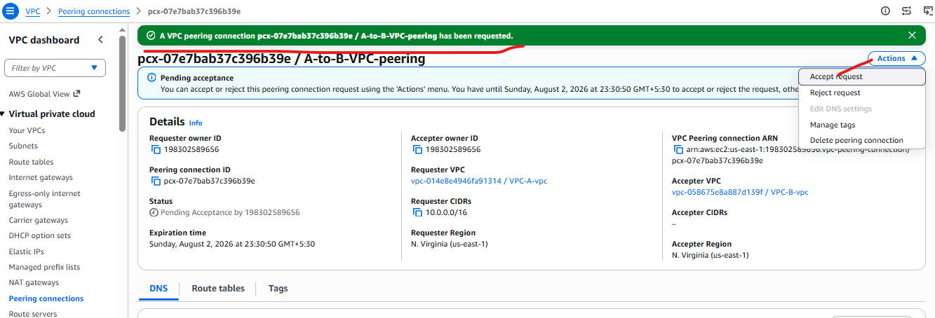

Now update the route tables of vpcs
[Open VPCA -> Instance id (Ec2 private intance)-> Select Subnet ID-> again subnet ID -> Route Table ID >] and vice versa for VPC -B
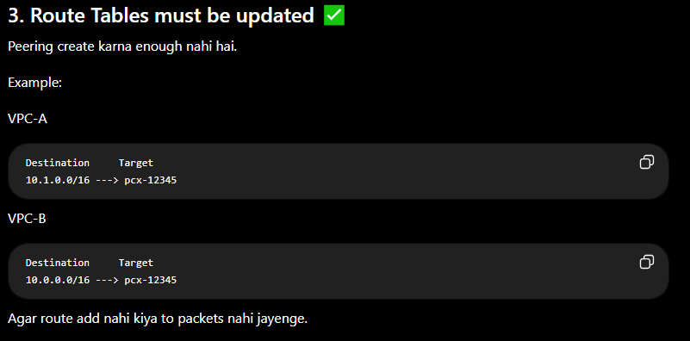
Update in VPC –A
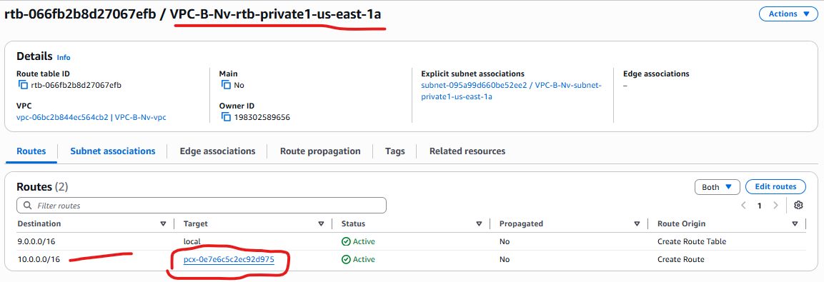

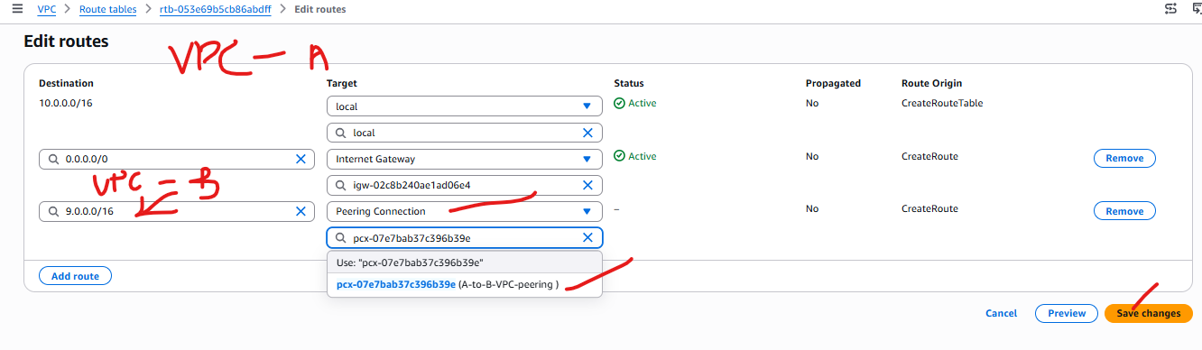

Now add CIDR of Vpc-A in the VPC –b subnet route table where Private-Server-vpc-B hosted.
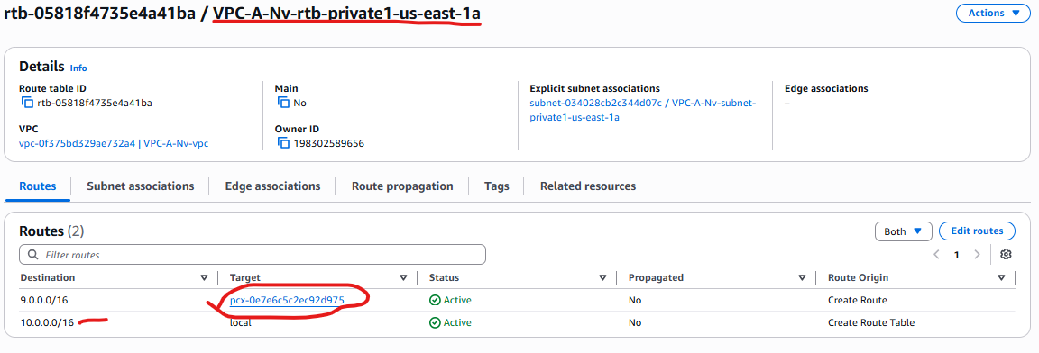

Now connect VPC-A Bastion host with ec2 private server
Again EC2 private server (VPC -A) EC2 private server (VPC-B)
